Spring REST using Spring Boot 3

Hello World RESTful Web Service

Write a REST service in the spring learn application created earlier, that returns the text "Hello World!!" using Spring Web Framework. Refer details below:  
  
**Method:** GET  
**URL:** /hello  
**Controller:** com.cognizant.spring-learn.controller.HelloController  
**Method Signature:** public String sayHello()  
**Method Implementation:** return hard coded string "Hello World!!"  
**Sample Request**: <http://localhost:8080/hello>

package com.cognizant.spring_learn.controller;

import org.slf4j.Logger;

import org.slf4j.LoggerFactory;

import org.springframework.web.bind.annotation.GetMapping;

import org.springframework.web.bind.annotation.RestController;

*@RestController*

public class HelloController {

private static final Logger ***LOGGER*** = LoggerFactory.*getLogger* (HelloController.class);

*@GetMapping*("/hello")

public String sayHello() {

***LOGGER***.info("START - sayHello()");

String message = "Hello World!!";

***LOGGER***.info("END - sayHello()");

return message;

}

}

URL - http://localhost:8083/hello in both,

* Chrome browser
* Postman.

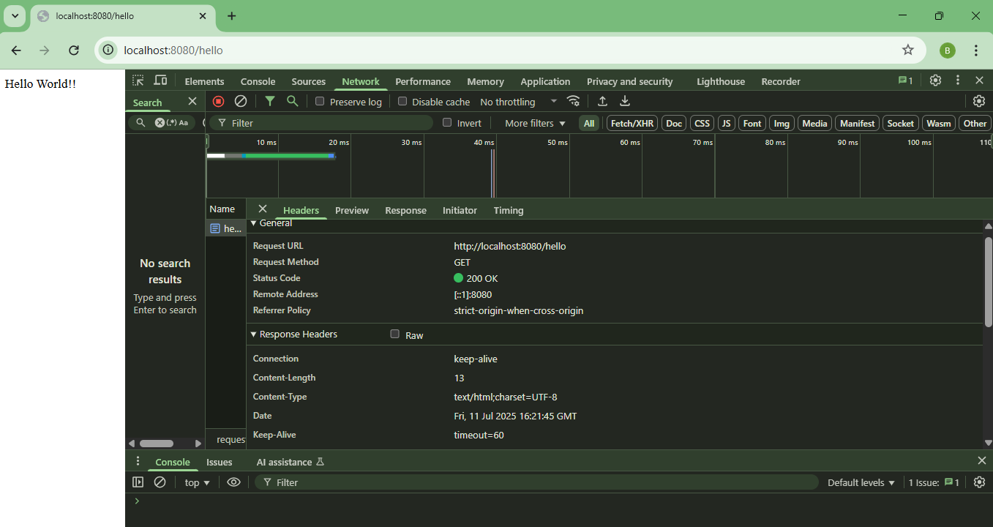

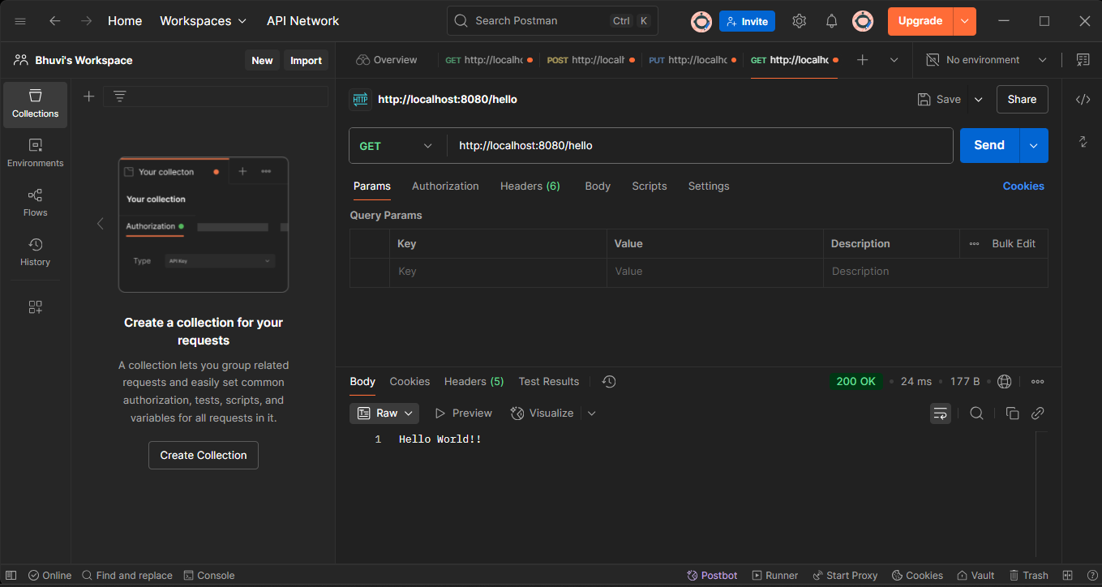

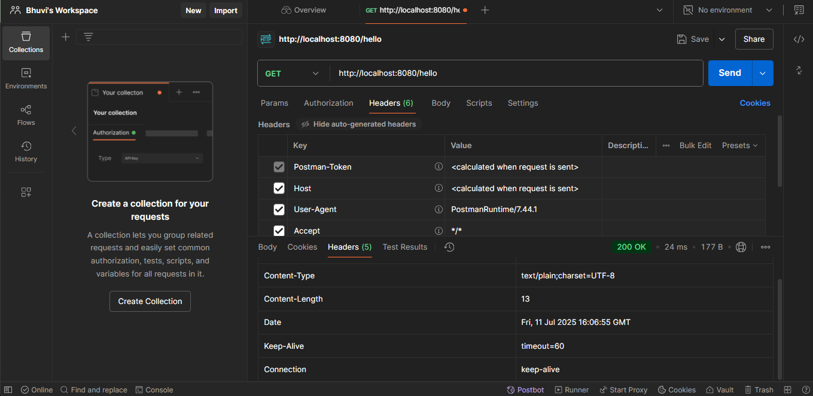

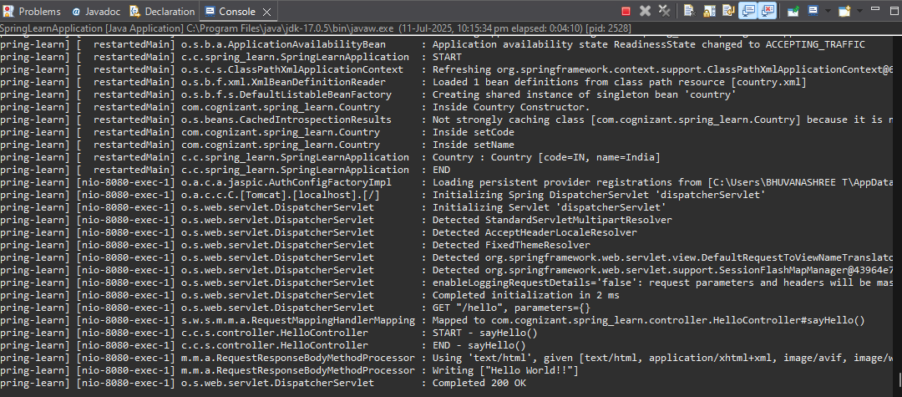

REST - Country Web Service

Write a REST service that returns India country details in the earlier created spring learn application.  
  
**URL**: /country  
**Controller**: com.cognizant.spring-learn.controller.CountryController  
**Method Annotation**: @RequestMapping  
**Method Name**: getCountryIndia()  
**Method Implementation**: Load India bean from spring xml configuration and return  
**Sample Request**: <http://localhost:8083/country>

Country.xml

<beans xmlns="http://www.springframework.org/schema/beans"

xmlns:xsi="http://www.w3.org/2001/XMLSchema-instance"

xsi:schemaLocation="http://www.springframework.org/schema/beans

https://www.springframework.org/schema/beans/spring-beans.xsd">

<bean id="country" class="com.cognizant.spring_learn.model.Country">

<property name="code" value="IN"/>

<property name="name" value="India"/>

</bean>

</beans>

Country.java

package com.cognizant.spring_learn.model;

public class Country {

private String code;

private String name;

public String getCode() {

return code;

}

public void setCode(String code) {

this.code = code;

}

public String getName() {

return name;

}

public void setName(String name) {

this.name = name;

}

}

CounryController.java

package com.cognizant.spring_learn.controller;

import com.cognizant.spring_learn.model.Country;

import org.slf4j.Logger;

import org.slf4j.LoggerFactory;

import org.springframework.context.ApplicationContext;

import org.springframework.context.support.ClassPathXmlApplicationContext;

import org.springframework.web.bind.annotation.RequestMapping;

import org.springframework.web.bind.annotation.RestController;

*@RestController*

public class CountryController {

private static final Logger ***LOGGER*** = LoggerFactory.*getLogger*(CountryController.class);

*@RequestMapping*("/country")

public Country getCountryIndia() {

***LOGGER***.info("START - getCountryIndia()");

ApplicationContext context = new ClassPathXmlApplicationContext("country.xml");

Country country = (Country) context.getBean("country");

***LOGGER***.info("END - getCountryIndia()");

return country;

}

}

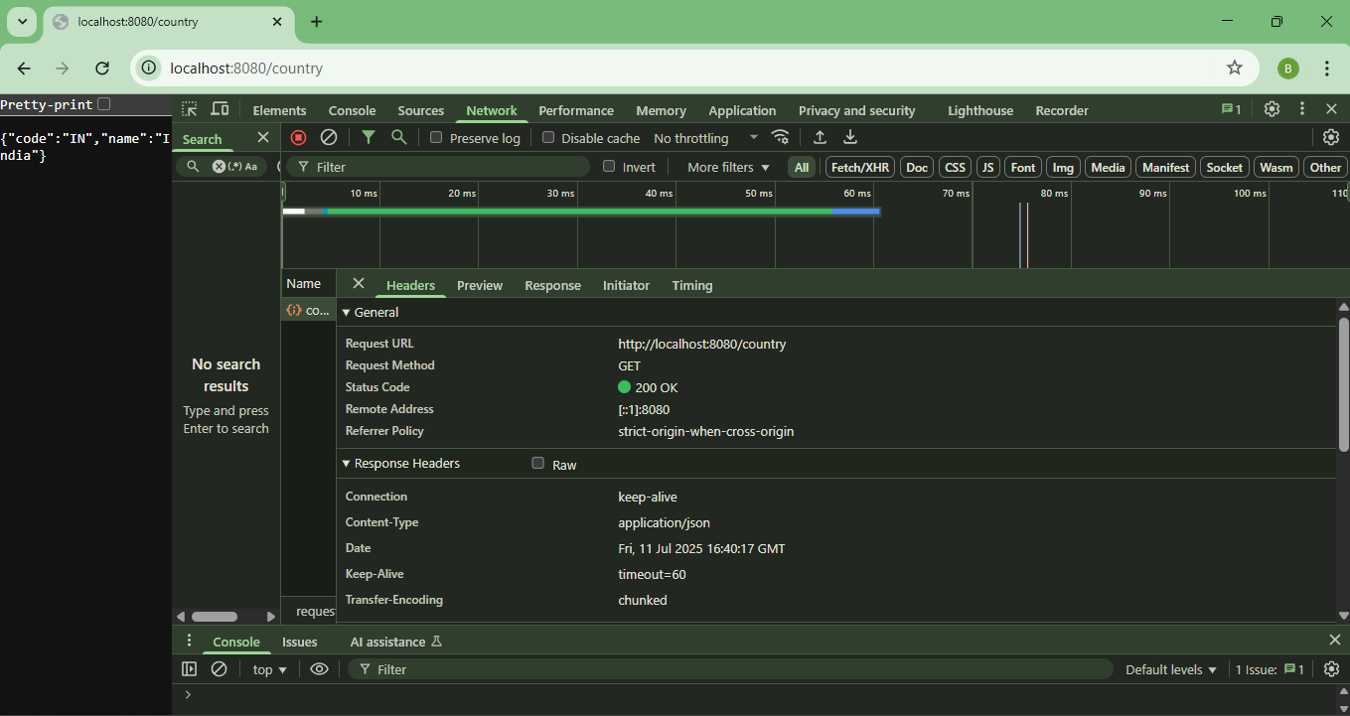

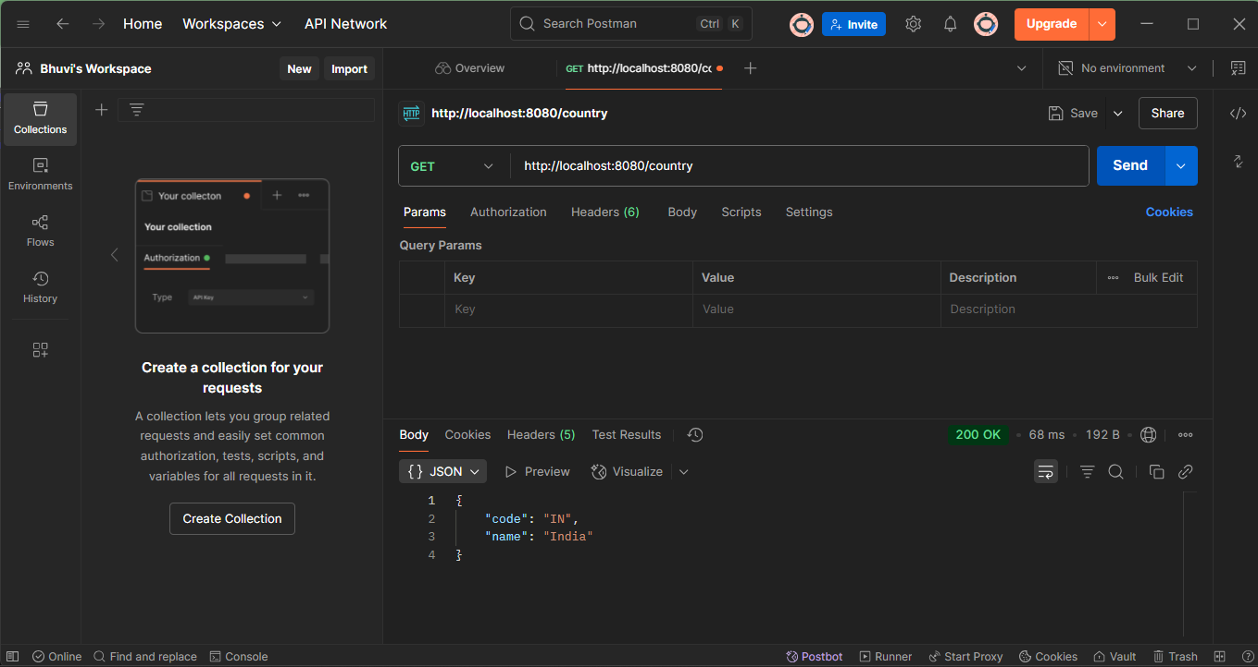

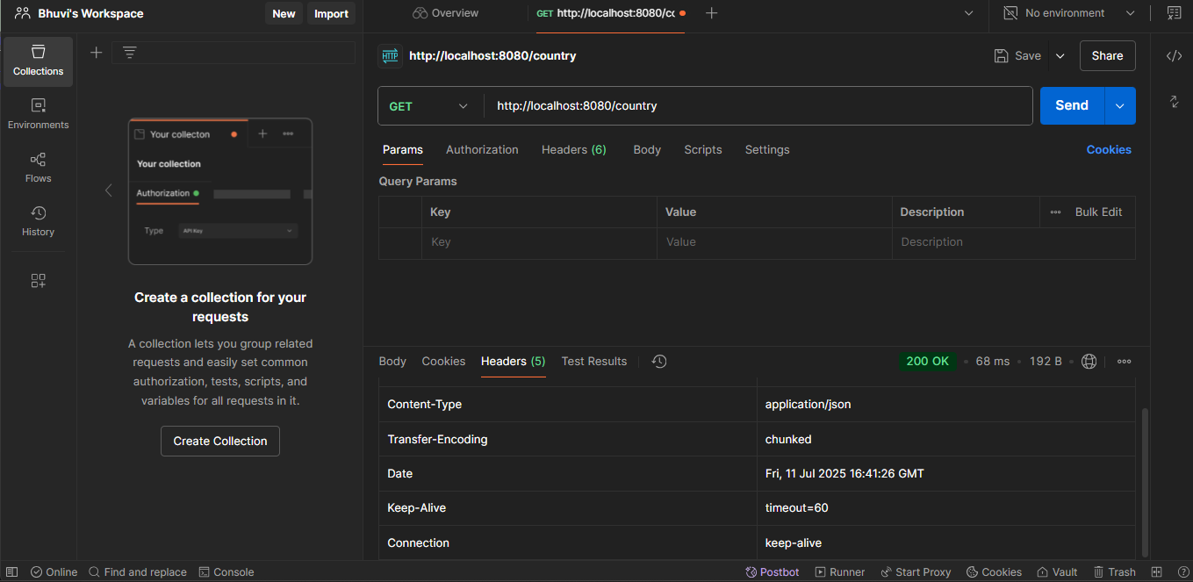

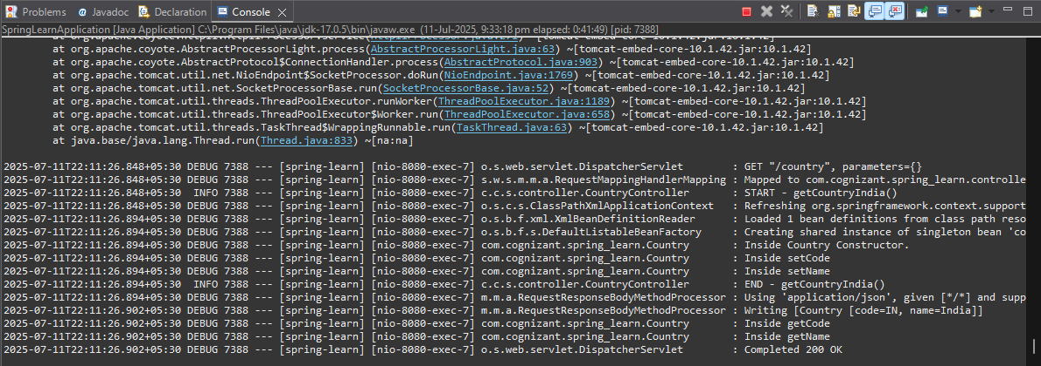

REST - Get country based on country code

Write a REST service that returns a specific country based on country code. The country code should be case insensitive.  
  
**Controller**: com.cognizant.spring-learn.controller.CountryController  
**Method Annotation:** @GetMapping("/countries/{code}")  
**Method Name**: getCountry(String code)  
**Method Implemetation**: Invoke countryService.getCountry(code)   
**Service Method:**com.cognizant.spring-learn.service.CountryService.getCountry(String code)  
  
**Service Method Implementation**:

* Get the country code using @PathVariable
* Get country list from country.xml
* Iterate through the country list
* Make a case insensitive matching of country code and return the country.
* Lambda expression can also be used instead of iterating the country list

**Sample Request**: <http://localhost:8083/country/in>

Country.xml

<beans xmlns="http://www.springframework.org/schema/beans"

xmlns:xsi="http://www.w3.org/2001/XMLSchema-instance"

xsi:schemaLocation="http://www.springframework.org/schema/beans

https://www.springframework.org/schema/beans/spring-beans.xsd">

<bean id="countryList" class="java.util.ArrayList">

<constructor-arg>

<list>

<bean class="com.cognizant.spring_learn.model.Country">

<property name="code" value="IN"/>

<property name="name" value="India"/>

</bean>

<bean class="com.cognizant.spring_learn.model.Country">

<property name="code" value="US"/>

<property name="name" value="United States"/>

</bean>

<bean class="com.cognizant.spring_learn.model.Country">

<property name="code" value="DE"/>

<property name="name" value="Germany"/>

</bean>

</list>

</constructor-arg>

</bean>

</beans>

Country.java

package com.cognizant.spring_learn.model;

public class Country {

private String code;

private String name;

// Getters and Setters

public String getCode() {

return code;

}

public void setCode(String code) {

this.code = code;

}

public String getName() {

return name;

}

public void setName(String name) {

this.name = name;

}

}

CountryController.java

package com.cognizant.spring_learn.controller;

import com.cognizant.spring_learn.model.Country;

import com.cognizant.spring_learn.service.CountryService;

import org.slf4j.Logger;

import org.slf4j.LoggerFactory;

import org.springframework.beans.factory.annotation.Autowired;

import org.springframework.web.bind.annotation.*;

*@RestController*

public class CountryController {

private static final Logger ***LOGGER*** = LoggerFactory.*getLogger*(CountryController.class);

*@Autowired*

private CountryService countryService;

*@GetMapping*("/countries/{code}")

public Country getCountry(*@PathVariable* String code) {

***LOGGER***.info("START - getCountry()");

Country country = countryService.getCountry(code);

***LOGGER***.info("END - getCountry()");

return country;

}

}

CountryService.java

package com.cognizant.spring_learn.service;

import java.util.List;

import org.springframework.context.ApplicationContext;

import org.springframework.context.support.ClassPathXmlApplicationContext;

import org.springframework.stereotype.Service;

import com.cognizant.spring_learn.model.Country;

*@Service*

public class CountryService {

private ApplicationContext context;

*@SuppressWarnings*("unchecked")

public Country getCountry(String code) {

context = new ClassPathXmlApplicationContext("country.xml");

List<Country> countryList = (List<Country>) context.getBean("countryList");

// Using Lambda expression for cleaner code

return countryList.stream()

.filter(c -> c.getCode().equalsIgnoreCase(code))

.findFirst()

.orElse(null); // returns null if no match found

}

}

